实验一
实验二
1.
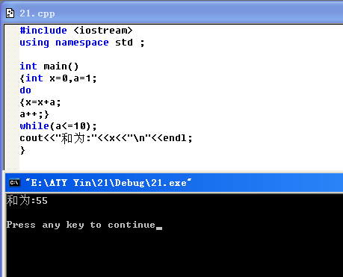
2
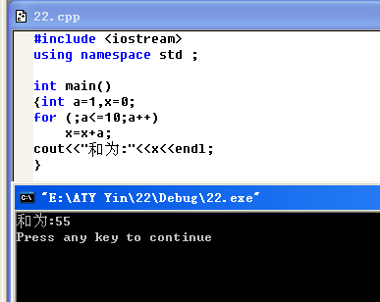
3
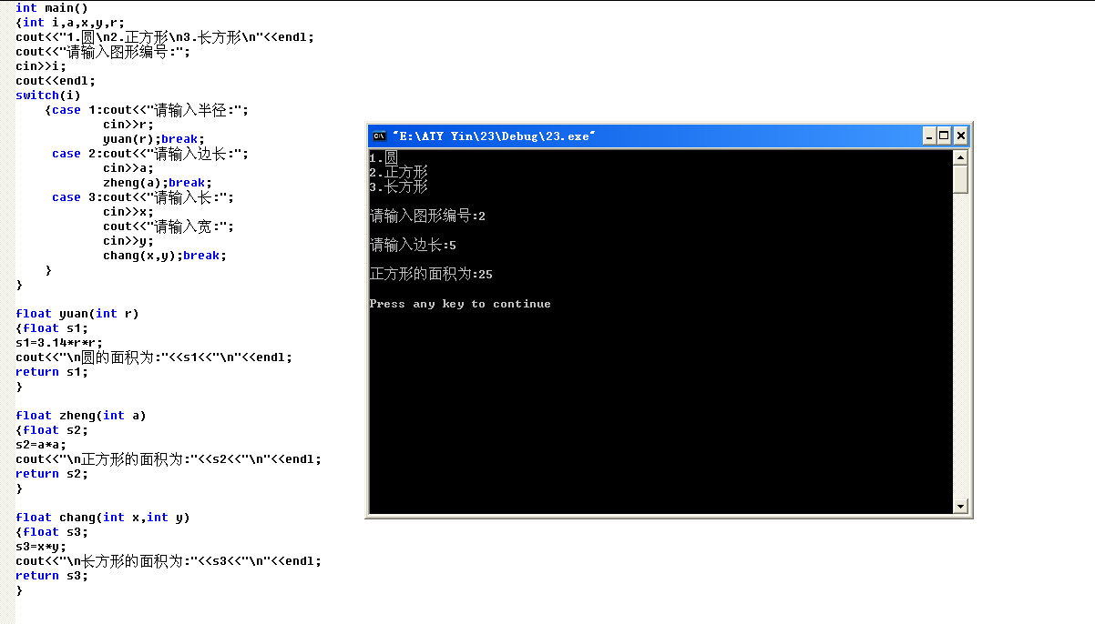
4
5
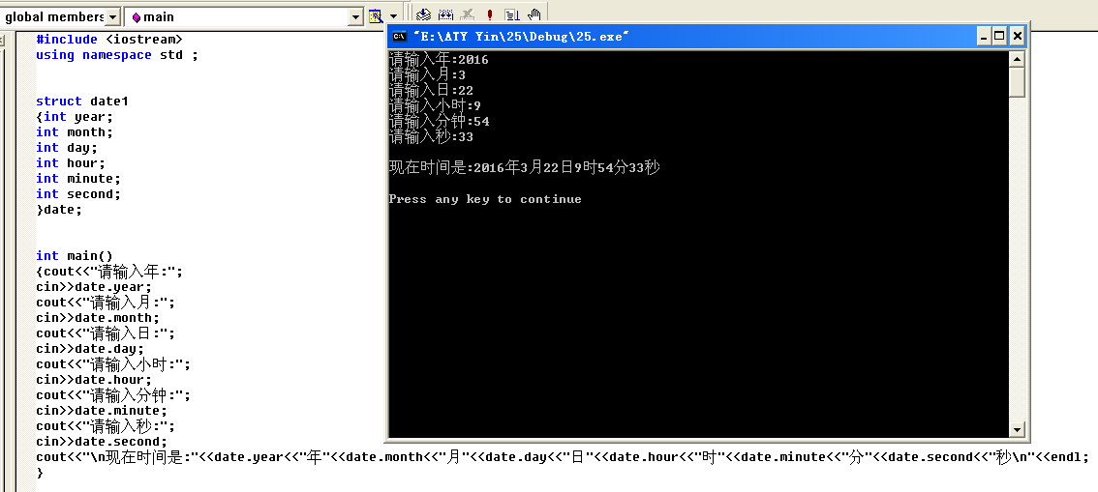
实验三
1
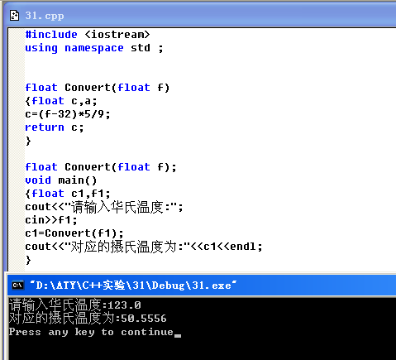
2

#include <iostream>
using namespace std ;

int Maxl(int a,int b);
int Maxl(int a,int b,int c);
double Maxl(double d,double e);
double Maxl(double d,double e,double f);
int main()
{int a,b,c,max0;
double d,e,f,max1;
cout<<"请输入两个整数:";
cin>>a>>b;
max0=Maxl(a,b);
cout<<"最大值为:"<<max0<<endl;
cout<<"请输入三个整数:";
cin>>a>>b>>c;
max0=Maxl(a,b,c);
cout<<"最大值为:"<<max0<<endl;
cout<<"请输入两个双精度数:";
cin>>d>>e;
max1=Maxl(d,e);
cout<<"最大值为:"<<max1<<endl;
cout<<"请输入三个双精度数:";
cin>>d>>e>>f;
max1=Maxl(d,e,f);
cout<<"最大值为:"<<max1<<endl;

}

int Maxl(int a,int b)
{int max;
if (a>b)
max=a;
else
max=b;
return max;
}

int Maxl(int a,int b,int c)
{int max;
if (a>b)
max=a;
else
max=b;
if (c>max)
max=c;
return max;
}

double Maxl(double d,double e)
{double max;
if (d>e)
max=d;
else
max=e;
return max;
}

double Maxl(double d,double e,double f)
{double max;
if (d>e)
max=d;
else
max=e;
if (f>max)
max=f;
return max;
}
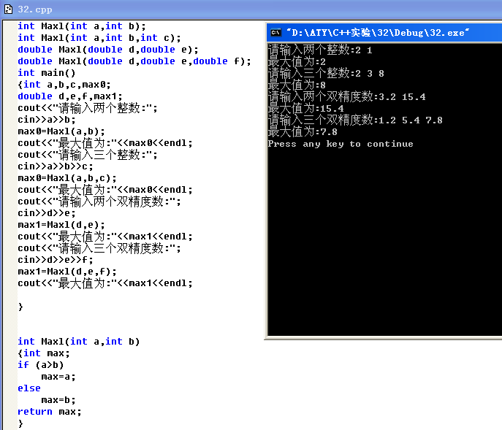
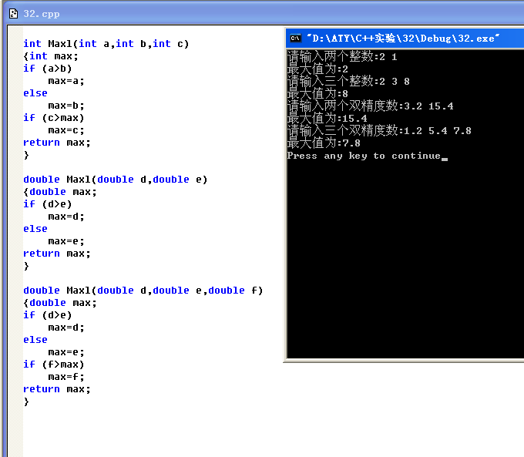
3
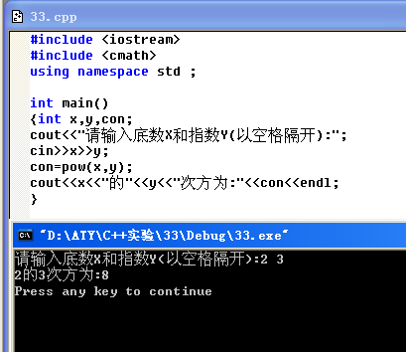
4
#include <iostream>
using namespace std ;

int fib(int n);
int main()
{int n,cons;
cout<<"Please input n:";
cin>>n;
cons=fib(n);
cout<<"Fibonacci is "<<cons<<endl;
}

int fib(int n)
{int Process;
if (n<3)
return 1;
else
{Process=fib(n-2)+fib(n-1);
return Process;}
}
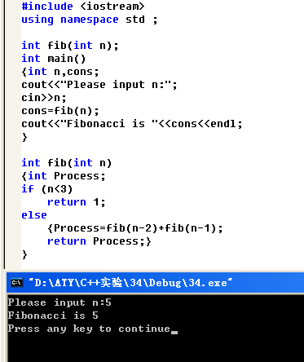

四
1
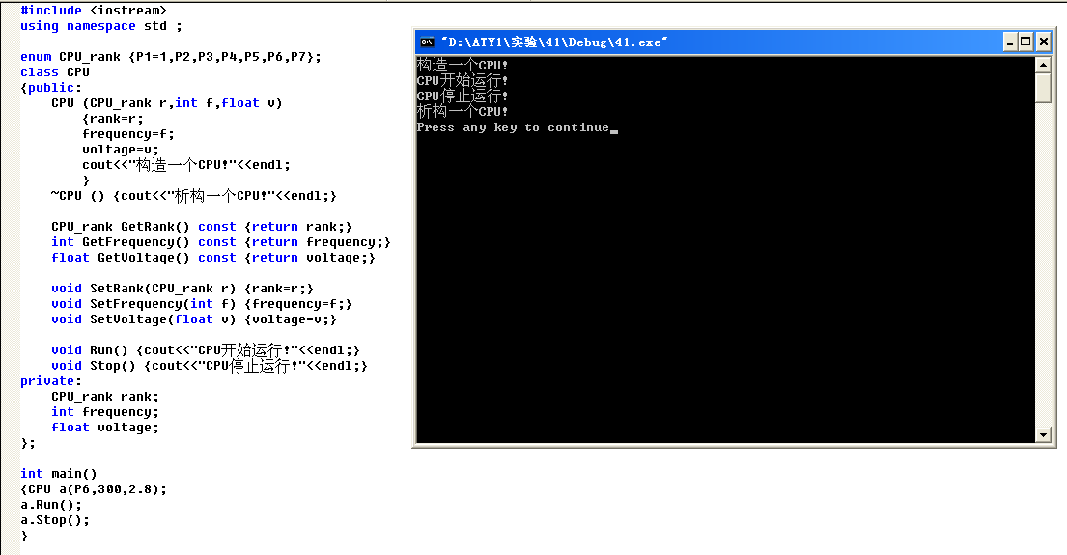
2
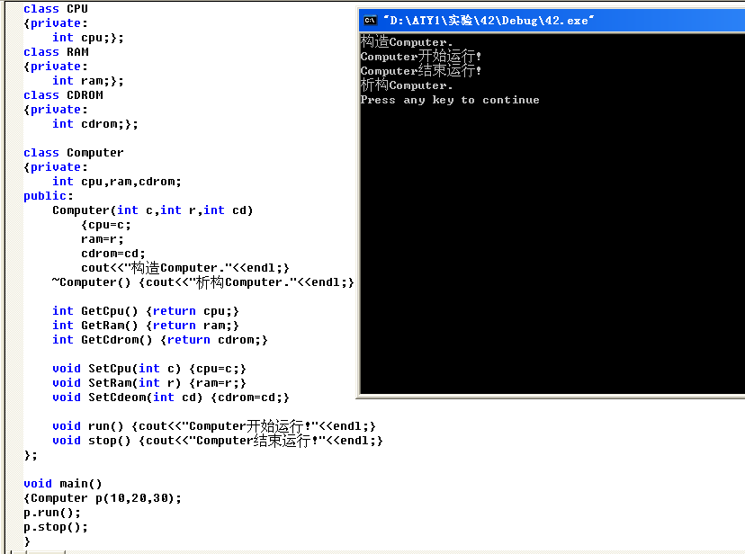
3

五
1
#include <iostream>
using namespace std;

void fn1();
int x=1,y=2;

int main()
{
cout<<"Begin..."<<endl;
cout<<"x="<<x<<endl;
cout<<"y="<<y<<endl;
cout<<"Evaluate x and y in main()..."<<endl;
int x=10,y=20;
cout<<"x="<<x<<endl;
cout<<"y="<<y<<endl;
cout<<"Step into fn1()..."<<endl;
fn1();
cout<<"Back in main"<<endl;
cout<<"x="<<x<<endl;
cout<<"y="<<y<<endl;
return 0;
}

void fn1()
{
int y=200;
cout<<"x="<<x<<endl;
cout<<"y="<<y<<endl;
}

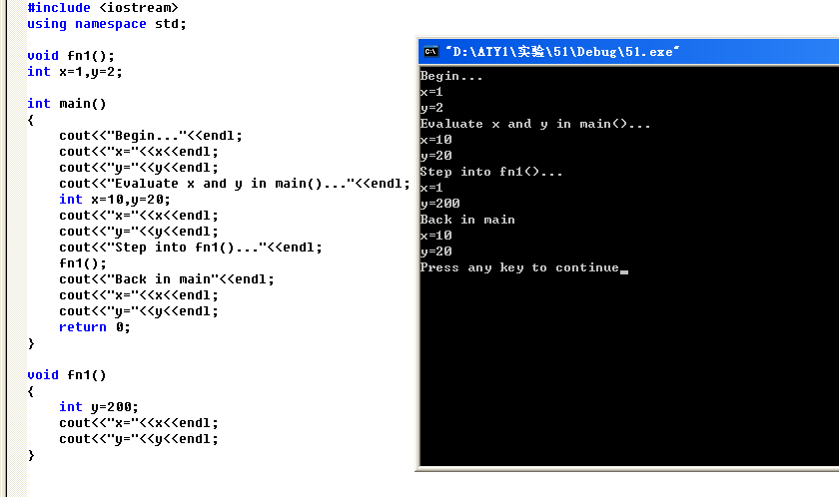
2

//client.h
#ifndef CLIENT_H
#define CLIENT_H

class Client
{
private:
static char ServerName;
static int ClientNum;
public:
Client() {}
static void ChangeServerName(char csn);
void get();
void show();
};

#endif

//client.cpp
#include <iostream>
using namespace std;
#include "client.h"

void Client::get()
{}

void Client::show()
{cout<<"ServerName is:"<<ServerName<<endl<<"ClientNum is:"<<ClientNum<<endl;}

void Client::ChangeServerName(char csn)
{cout<<"ChangeServerName is:"<<csn<<endl;}

char Client::ServerName=87;
int Client::ClientNum=2;

//clienttest.cpp
#include <iostream>
using namespace std;
#include "client.h"

int main()
{
Client a;
a.get();
a.show();
a.ChangeServerName(65);
return 0;
}

Before change
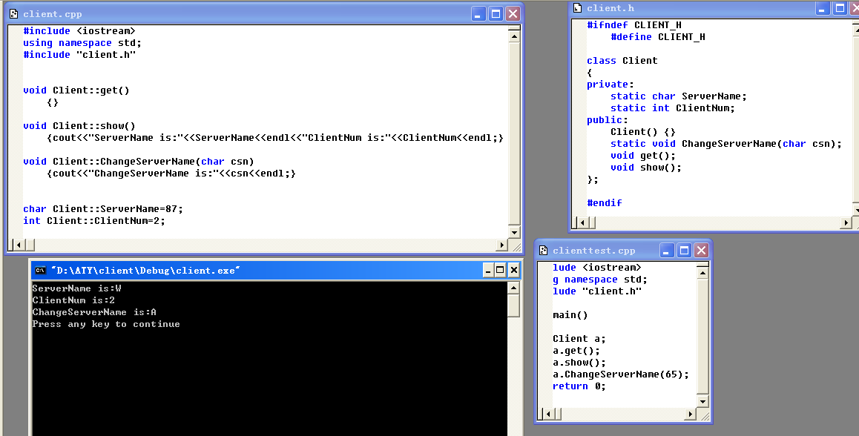
After change
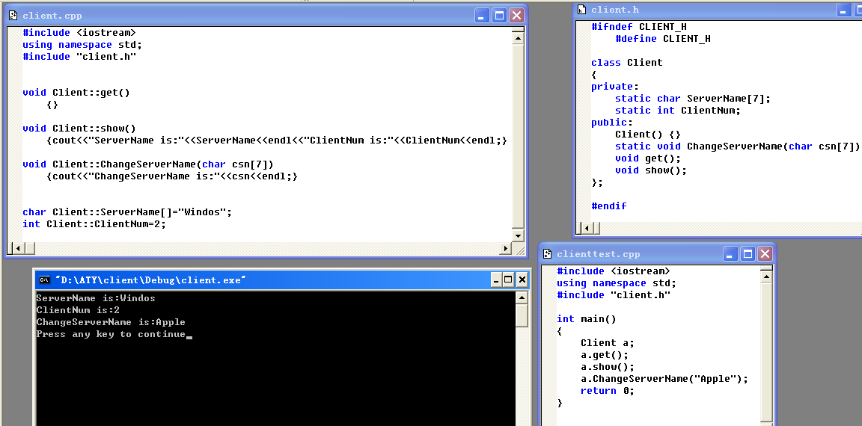
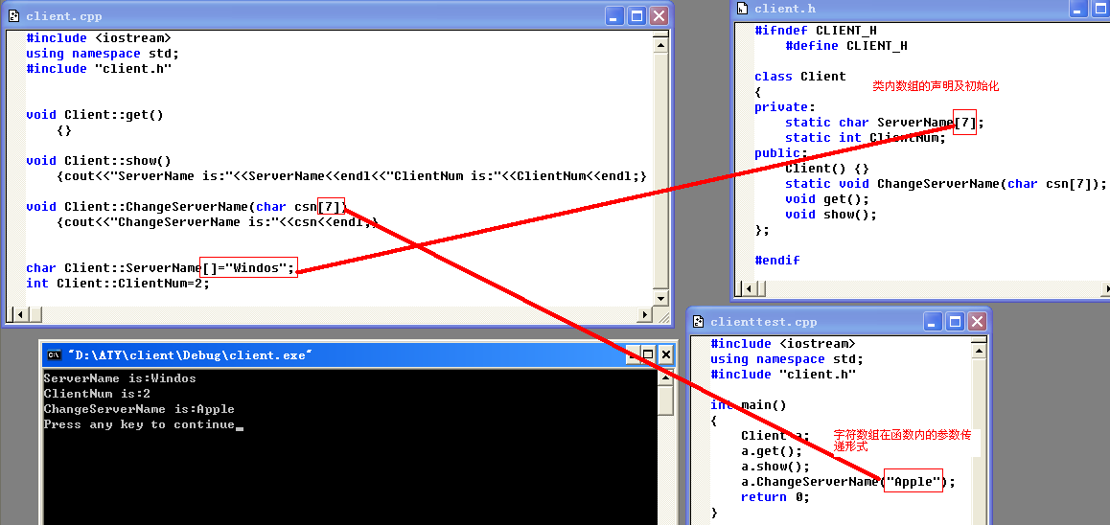

六
1

#include <iostream>
using namespace std;
void chgfun()
{
int chga[3][3]={0},chgb[3][3]={0};
int i,j;
cout<<"Please input array A:";
for(i=0;i<3;i++)
for(j=0;j<3;j++)
cin>>chga[i][j];
for(i=0;i<3;i++)
for(j=0;j<3;j++)
chgb[i][j]=chga[j][i];
cout<<"After change:"<<endl;
for(i=0;i<3;i++)
{for(j=0;j<3;j++)
cout<<chgb[i][j]<<" ";
cout<<endl;}
}

int main()
{
chgfun();
return 0;
}

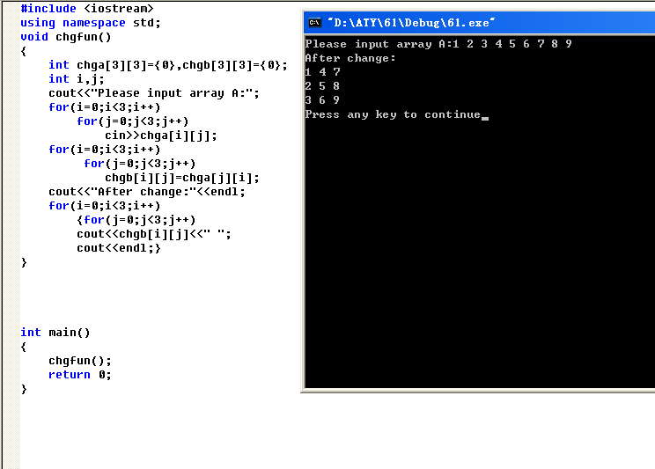

2

3

#include <iostream.h>
#include <string.h>

void link()
{char str1[100]={'\0'},str2[40]={'\0'};
int i,j,k,n;
cout<<"Please input your string1:";
cin>>str1;
cout<<"Please input your string2:";
cin>>str2;
n=strlen(str1);
for(i=0;i<100;i++)
str1[n+i]=str2[i];
cout<<"The string after link:"<<str1<<endl;
}

main()
{
link();
}

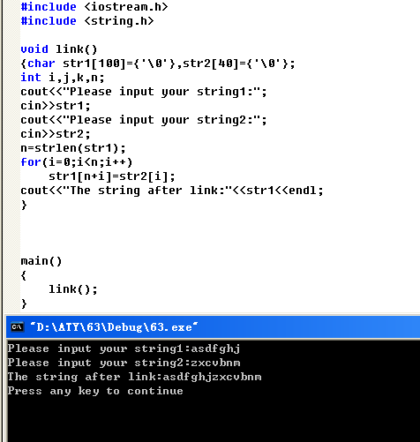
4
#include <iostream>
#include <string>
using namespace std;

void link()
{
string str1;
string str2;
int i,j,k,n;
cout<<"Please input your string1 and string2:";
getline(cin,str1,',');
getline(cin,str2);
// cout<<"Please input your string2:";
// n=strlen(str1);
// for(i=0;i<100;i++)
// str1[n+i]=str2[i];
str1=str1+str2;
cout<<"The string after link:"<<str1<<endl;
}

main()
{
link();
}

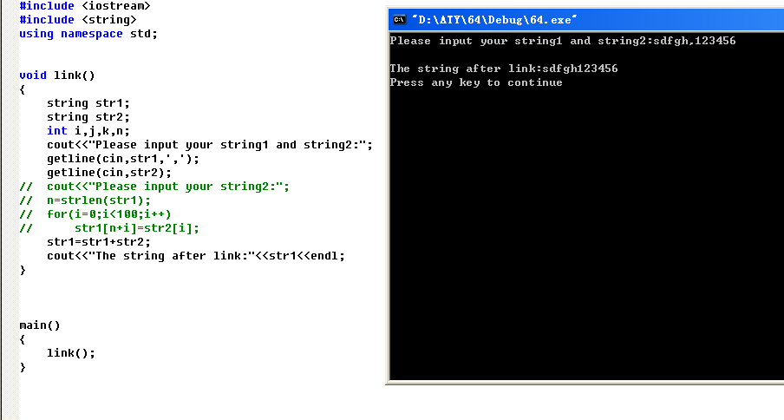

5
//65.h
#include <iostream.h>
#include <string.h>

class Employee
{
private:
char name[10],name0[10],address[10],city[10];
int adnumber;
public:
Employee(){}
void get(char name1[],char address1[],char city1[],int adnumber1)
{strcpy(name,name1);
strcpy(address,address1);
strcpy(city,city1);
adnumber=adnumber1;
}
void change_name(char name2[])
{strcpy(name0,name2);}
void display(int n);
};
//65.cpp
#include <iostream.h>
#include "65.h"

void Employee::display(int n)
{if(n==0)
cout<<"Before change name"<<endl<<"Name:"<<name<<endl<<"Adress:"<<address<<endl<<"City:"<<city<<endl<<"Adressnumber:"<<adnumber<<endl;
else
cout<<"After change name"<<endl<<"Name:"<<name0<<endl<<"Adress:"<<address<<endl<<"City:"<<city<<endl<<"Adressnumber:"<<adnumber<<endl;
}

main()
{
char nm[10];
Employee a;
a.get("Shield","Unknow","Newyork",007);
a.display(0);
cin>>nm;
a.change_name(nm);
a.display(1);
}

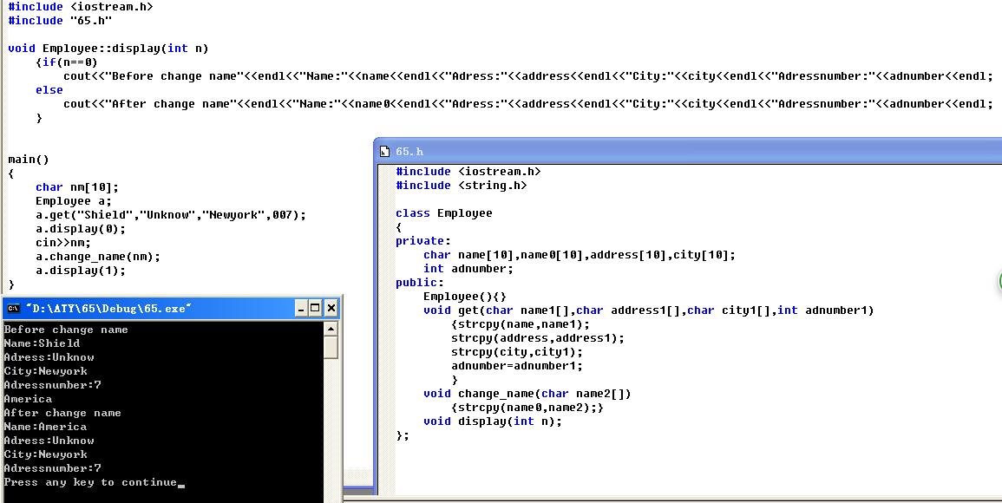
6
//66.h
#include <iostream.h>
#include <string.h>

class Employee
{
private:
char name[10],name0[10],address[10],city[10];
int adnumber;
public:
Employee(){}
~Employee(){}
void get(int n)
{char name1[10],address1[10],city1[10];
int adnumber1;
cout<<"Please input your name"<<n+1<<" and address"<<n+1<<" and city"<<n+1<<" and addressnumber"<<n+1<<":"<<endl;
cin>>name1>>address1>>city1>>adnumber1;
strcpy(name,name1);
strcpy(address,address1);
strcpy(city,city1);
adnumber=adnumber1;}
void change_name(char name2[])
{strcpy(name0,name2);}
void display(int m)
{
cout<<"Name"<<m+1<<":"<<name<<" Adress"<<m+1<<":"<<address<<" City"<<m+1<<":"<<city<<" Adressnumber"<<m+1<<":"<<adnumber<<endl;
}
};
//66.cpp
#include <iostream.h>
#include "66.h"

main()
{
int i;
Employee *emp=new Employee[5];
for(i=0;i<5;i++)
emp[i].get(i);
for(i=0;i<5;i++)
emp[i].display(i);
}

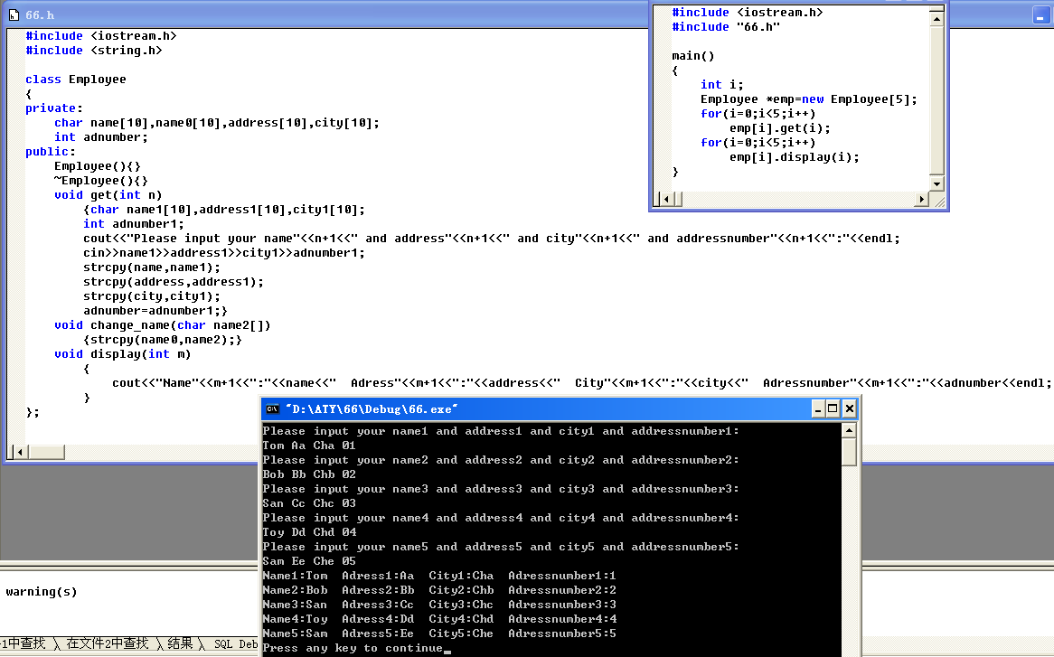

六
1
#include <iostream>
using namespace std;

class Animal
{
public:
int age;
};

class dog:virtual public Animal
{
public:
void SetAge(int n)
{age=n;
cout<<age<<endl;}
};

void main()
{
int i=2;
dog d;
d.SetAge(i);
}

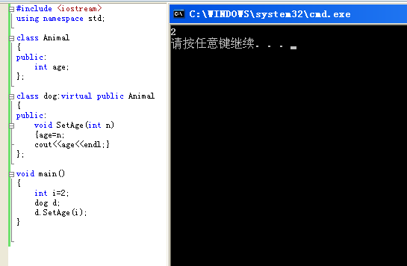
2
#include <iostream>
using namespace std;

class BaseClass
{
public:
int Number;
BaseClass(int i)
{
cout<<"Construct has been called!"<<endl;
}
~BaseClass()
{
cout<<"Destruct has been called!"<<endl;
}
};

class DerivedClass:public BaseClass
{
public:
DerivedClass(int a):BaseClass(a)
{}
};

int main()
{
DerivedClass no1(2);
return 0;
}

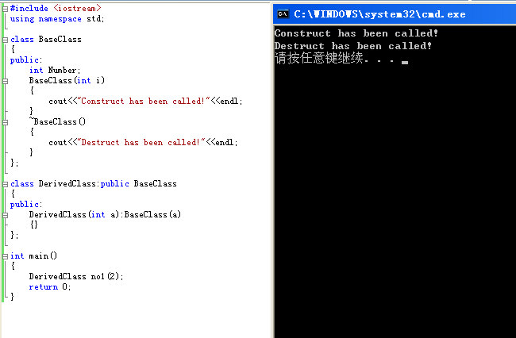

3
#include <iostream>
using namespace std;

class car
{
public:
int MaxSpeed;
int Weight;
car(){cout<<"Construct of car has been called!"<<endl;}
~car(){cout<<"Destruct of car has been called!"<<endl;}
void Run(){cout<<"Run!"<<endl;}
void Stop(){cout<<"Stoped!"<<endl;}
};

class bicycle:virtual public car
{
public:
bicycle(){cout<<"Construct of bicycle has been called!"<<endl;}
~bicycle(){cout<<"Destruct of bicycle has been called!"<<endl;}
int Height;
};

class motocar:virtual public car
{
public:
motocar(){cout<<"Construct of motocar has been called!"<<endl;}
~motocar(){cout<<"Destruct of motocar has been called!"<<endl;}
int SeatNum;
};

class motocycle:public bicycle,public motocar
{
public:
motocycle(){cout<<"Construct of motocycle has been called!"<<endl;}
~motocycle(){cout<<"Destruct of motocycle has been called!"<<endl;}
void Show(int a,int b,int c,int d)
{
MaxSpeed=a;
Weight=b;
Height=c;
SeatNum=d;
cout<<MaxSpeed<<"\t "<<Weight<<"\t "<<Height<<"\t "<<SeatNum<<"\n\n"<<endl;
}
};

int main()
{
motocycle c1;
cout<<"\n\n"<<"MaxSpeed "<<"Weight "<<"Height "<<"SeatNum"<<endl;
c1.Show(2,4,6,8);
return 0;
}

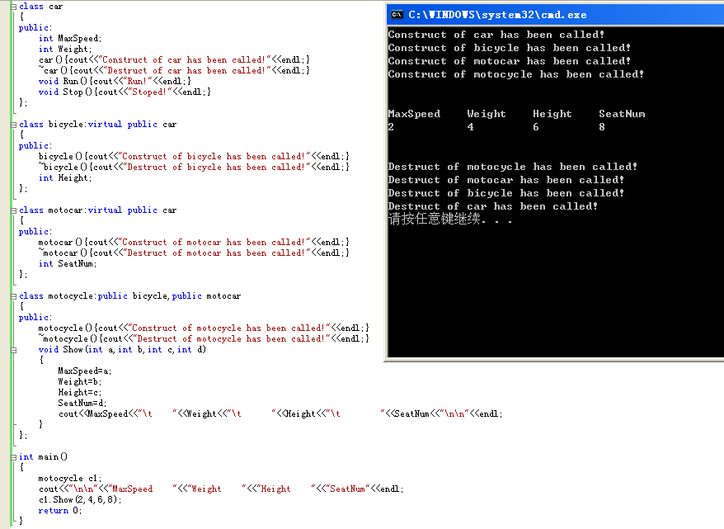

4

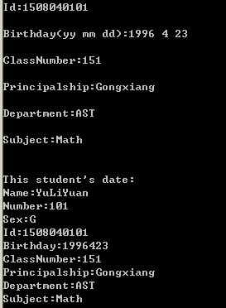

#include <string.h>
#include <iostream>
using namespace std;

class people
{
public:
char name[10];
int num;
char sex; //'b'&'g'
int id;
int year,month,day;
void getpeople()
{
char name1[10];int num1;char sex1;int id1;int yy;int mm;int dd;
cout<<"Name:";cin>>name1;cout<<"\nNumber:";cin>>num1;cout<<"\nSex:";cin>>sex1;cout<<"\nId:";cin>>id1;cout<<"\nBirthday(yy mm dd):";cin>>yy>>mm>>dd;
strcpy(name,name1);num=num1;sex=sex1;id=id1;year=yy;month=mm;day=dd;
}
};

class student:virtual public people
{
public:
char clasNO[7];
void getstudent()
{
char NO[7];
cout<<"\nClassNumber:";cin>>NO;
strcpy(clasNO,NO);
}
};

class teacher:virtual public people
{
public:
char principalship[11];
char department[21];
void getteacher()
{
char prin[11];char depart[21];
cout<<"\nPrincipalship:";cin>>prin;cout<<"\nDepartment:";cin>>depart;
strcpy(principalship,prin);strcpy(department,depart);
}
};

class graduate:virtual public student
{
public:
char subject[21];
teacher adviser;
void getgraduate()
{
char sub[21];
cout<<"\nSubject:";cin>>sub;
strcpy(subject,sub);
}
};

class TA:public graduate,public teacher
{
public:
void showTA()
{
cout<<"\n\nThis student's date:"<<"\nName:"<<name<<"\nNumber:"<<num<<"\nSex:"<<sex<<"\nId:"<<id<<"\nBirthday:"<<year<<month<<day<<"\nClassNumber:"<<clasNO<<"\nPrincipalship:"<<principalship<<"\nDepartment:"<<department<<"\nSubject:"<<subject<<"\n"<<endl;
}
};

int main()
{
TA ta1;
/* char name2[5];
int num2;
char sex2; //'b'&'g'
int id2;
int year2,month2,day2;
char clasNO2[7];
char principalship2[11];
char department2[21];
char subject2[21];*/

printf("Please input:\nName Number Sex Id Birthady ClassNumber Principalship Department Subject\n");

ta1.getpeople();
ta1.getstudent();
ta1.getteacher();
ta1.getgraduate();
ta1.showTA();
}

八
1
#include <iostream>
using namespace std;

class point
{
public:
point(int xx=0,int yy=0):_x(xx),_y(yy){}
point operator ++();
point operator ++(int);
point operator --();
point operator --(int);
private:
int _x,_y;
};

point point::operator ++()
{
_x+=1;_y+=1;
cout<<"++(x,y)=("<<_x<<","<<_y<<")"<<endl;
return point(_x+=1,_y+=1);
}
point point::operator ++(int)
{
int x1=_x,y1=_y;
cout<<"(x,y)++=("<<x1<<","<<y1<<")"<<endl;
_x+=1;_y+=1;
return point(x1,y1);
}
point point::operator --()
{
_x-=1;_y-=1;
cout<<"--(x,y)=("<<_x<<","<<_y<<")"<<endl;
return point(_x-=1,_y-=1);
}
point point::operator --(int)
{
int x1=_x,y1=_y;
cout<<"(x,y)--=("<<x1<<","<<y1<<")"<<endl;
_x-=1;_y-=1;
return point(x1,y1);
}

void main()
{
int x,y;
cin>>x>>y;
point p(x,y),p1=p,p2=p,p3=p,p4=p,q1,q2,q3,q4;
q1=++p1;
q2=p2++;
q3=--p3;
q4=p4--;
}

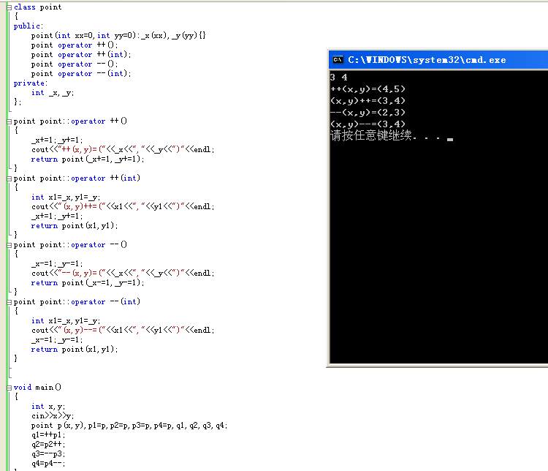
2
#include <iostream>
using namespace std;

class car
{
public:
int MaxSpeed;
int Weight;
car(){cout<<"Construct of car has been called!"<<endl;}
~car(){cout<<"Destruct of car has been called!"<<endl;}
virtual void Run(){cout<<"\nRun!"<<endl;}
virtual void Stop(){cout<<"\nStoped!\n"<<endl;}
};

class bicycle:virtual public car
{
public:
bicycle(){cout<<"Construct of bicycle has been called!"<<endl;}
~bicycle(){cout<<"Destruct of bicycle has been called!"<<endl;}
int Height;
};

class motocar:virtual public car
{
public:
motocar(){cout<<"Construct of motocar has been called!"<<endl;}
~motocar(){cout<<"Destruct of motocar has been called!"<<endl;}
int SeatNum;
};

class motocycle:public bicycle,public motocar
{
public:
motocycle(){cout<<"Construct of motocycle has been called!"<<endl;}
~motocycle(){cout<<"Destruct of motocycle has been called!"<<endl;}
void Show(int a,int b,int c,int d)
{
MaxSpeed=a;
Weight=b;
Height=c;
SeatNum=d;
cout<<MaxSpeed<<"\t "<<Weight<<"\t "<<Height<<"\t "<<SeatNum<<endl;
}
};

int main()
{
motocycle c1;
c1.Run();
cout<<"\n"<<"MaxSpeed "<<"Weight "<<"Height "<<"SeatNum"<<endl;
c1.Show(2,4,6,8);
c1.Stop();
return 0;
}
3

4
#include <math.h>
#include <iostream>
using namespace std;

class shape
{
public:
shape(){}
virtual void area()=0;
virtual void per()=0;
virtual void display()=0;
};

class circle:public shape
{
public:
circle(int r1):r(r1){}
int r;
void display()
{
cout<<"Please input R of the circle:";
cin>>r;
}
void area()
{
cout<<"The area of the circle is:"<<3.14*r*r<<endl;
}
void per()
{
cout<<"The perimeter of the circle is:"<<2*3.14*r<<"\n"<<endl;
}
};

class rectangle:public shape
{
public:
rectangle(int a1,int b1):a(a1),b(b1){}
int a,b;
void display()
{
cout<<"Please input A and B of the rectangle:";
cin>>a>>b;
}
void area()
{
cout<<"The area of the rectangle is:"<<a*b<<endl;
}
void per()
{
cout<<"The perimeter of the rectangle is:"<<2*(a+b)<<"\n"<<endl;
}
};

class triangle:public shape
{
public:
triangle(int l1,int m1,int n1):l(l1),m(m1),n(n1){}
int l,m,n;
void display()
{
cout<<"Please input L&M&N of the tirangle:";
cin>>l>>m>>n;
}
void area()
{
float p,ss;
p=(l+m+n)/2;
ss=p*(p-l)*(p-m)*(p-n);
cout<<"The area of the triangle is:" <<sqrt(ss)<<endl;
}
void per()
{
cout<<"The perimeter of the triangle is:"<<l+m+n<<"\n"<<endl;
}
};

void areas(shape *ptrA)
{
ptrA->area();
}
void pers(shape *ptrP)
{
ptrP->per();
}

int main()
{
circle C(0);
rectangle R(0,0);
triangle T(0,0,0);
int r,a,b,l,m,n;
C.display();areas(&C);pers(&C);
R.display();areas(&R);pers(&R);
T.display();areas(&T);pers(&T);
return 0;
}

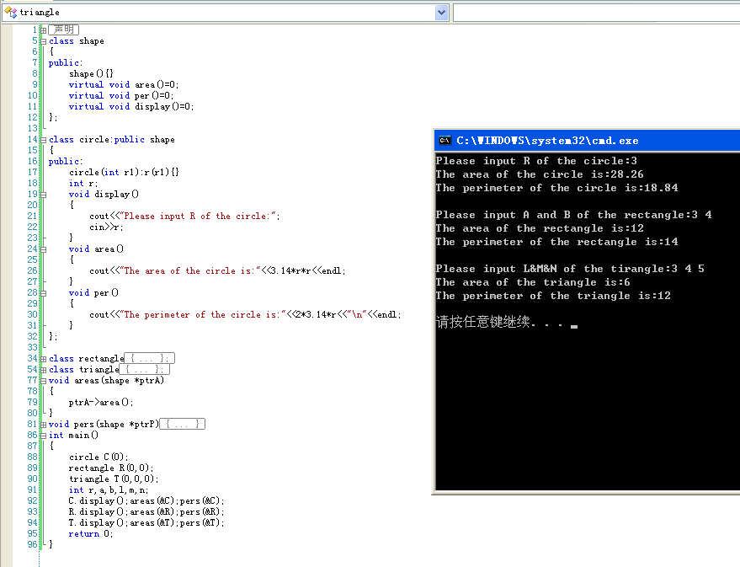

十一

十二
#include <iostream>
using namespace std;

class CExption
{
public:
void Reason(int x)
{
if(x==2)
cout<<"Your input is not within 0-9!\n\nPlease input a number(0--9):";
else if(x==1)
cout<<"Your input is not a number!\n\nPlease input a number(0--9):";
}
};

void fn1()
{
char y[10]={'\0'},n;
cin>>y;
if(y[0]>=48&&y[0]<=57&&y[1]=='\0')
cout<<"The number you input is:"<<y<<"\n"<<endl;
else if(y[0]<48||y[0]>57)
throw 1;
else if(y[1])
throw 2;
}

int main()
{
CExption E;
int e;
cout<<"Please input a number(0--9):";
do
{
e=0;
try
{
fn1();
}
catch(int j)
{
E.Reason(j);
e=j;
}
}while(e);
return 0;
}

